Ideation Phase
Empathize & Discover

Date | 20 February 2026
Team ID | LTVIP2026TMIDS65579
Project Name | Importing & Securing Data in ServiceNow
Maximum Marks | 4 Marks

Empathy Map Canvas:
The empathy map highlights the challenges faced by IT administrators and data managers while importing and securing data in ServiceNow. Users express concerns about time-consuming manual processes and potential security vulnerabilities. They think about implementing automated import mechanisms and strict role-based access controls to ensure data confidentiality. Their actions involve configuring Import Sets, Transform Maps, Roles, and ACL rules. Emotionally, they experience stress due to possible data breaches but feel confident when proper security mechanisms are implemented. This understanding helps in designing a solution that improves efficiency and ensures secure data handling
Example:
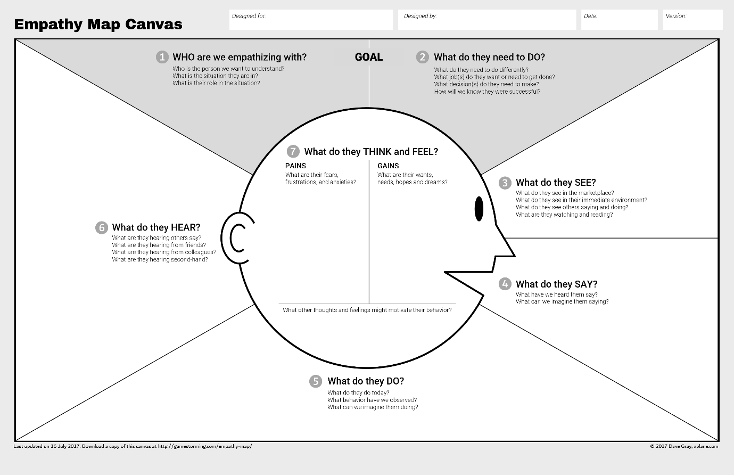

Reference: https://www.mural.co/templates/empathy-map-canvas

Example: 2

